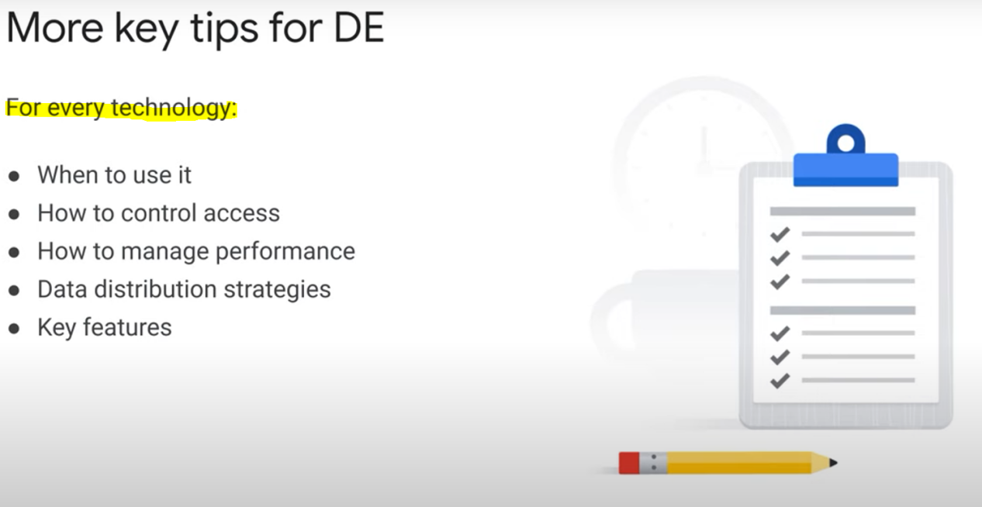

* When you are uncertain about a question, answer it + mark it as unsure (you’ll have the option to do that via a button during the exam!).

* Do the very easy questions first, skip the hard ones after answering randomly and marking them as unsure.

**What questions would you want to ask a client?**

You can make reasonable assumptions about a case. But if you seem to be missing information, especially technical information, that may be useful. It may help constrain the degree of freedom and limit the number of potentially correct answers. It might indicate that an answer is incorrect. In other words, use what you don't know or what is missing in the case to help you evaluate the intent of the question. Make sure you know what is being asked. **If you find yourself speculating and trying to add information to the case beyond reasonable assumptions, then you might be drifting off of the intent of the question.**